Week 4 GOAL’s

I4.1. Explain the term ‘aggregate functions’ and discuss their usage:

What are Aggregate Functions?:
Aggregate functions in SQL perform calculations on multiple rows and return a single value. They are used in data summarization.;

Common Aggregate Functions:
- AVG(column_name) → Returns the average value of a column.
- MAX(column_name) → Returns the maximum value.
- MIN(column_name) → Returns the minimum value.
- SUM(column_name) → Returns the total sum of a column.
- COUNT(column_name) → Returns the number of rows.

Where are they used?:
- Reports & Analytics (total sales, highest-selling products).
- Summarizing data (average price of products).
- Finding extreme values (most expensive or cheapest product).
- Filtering data in HAVING clauses (listing customers with total purchases above a certain amount).

I4.2. List the average product price:

I used (SELECT AVG(Price) AS Average_Product_Price FROM Product;) , to get the average product price of 113.66667

Screenshot:
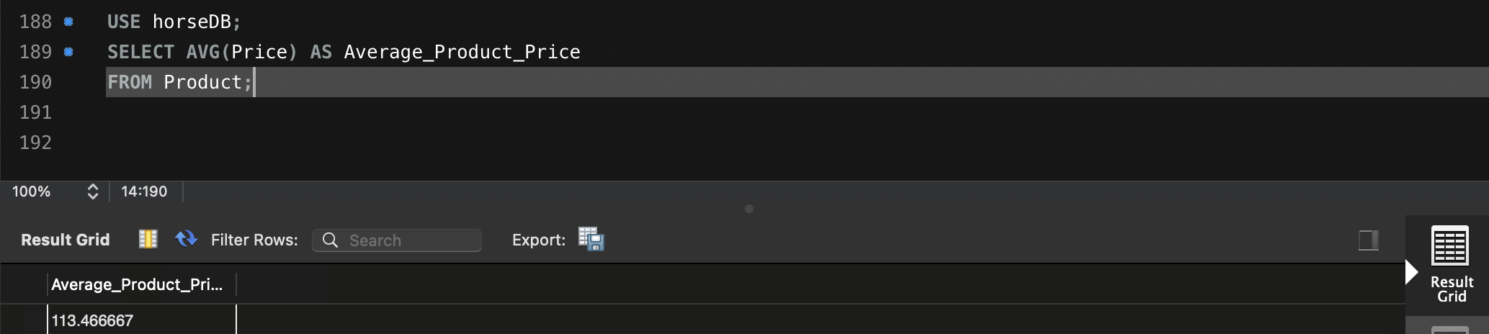

I4.3. List the maximum and minimum credit limit of all customers:
I used (SELECT MAX(Credit_Limit) AS Max_Credit_Limit, MIN(Credit_Limit) AS Min_Credit_Limit FROM Customer;) , to get the maximum and minimum credit limit of all customers

Screenshot:
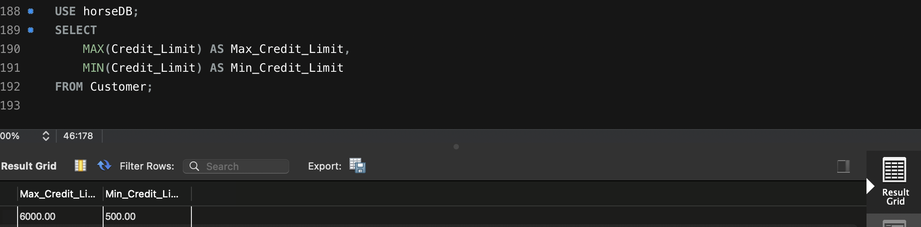

I4.4. List the customer number and name of all customers in descending order of
customer name:

I used (SELECT Customer_No, CName FROM Customer ORDER BY CName DESC;) to List the customers number and name.

Screenshot:
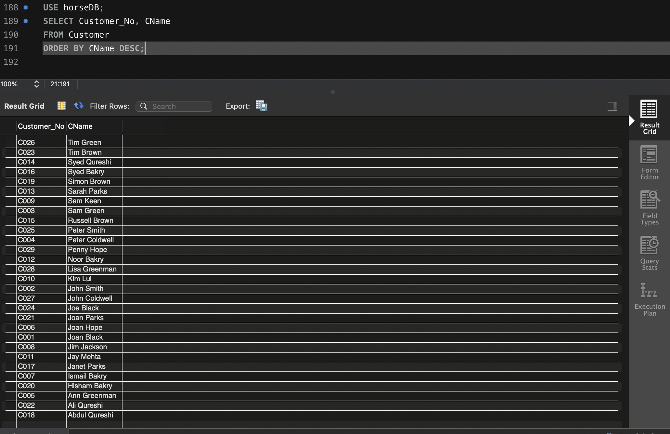

I4.5. List the product number, price, and warehouse number of all products in
ascending order of warehouse number and descending order of product
price:

Here I list the product number, price, and warehouse number, sorted:
- Ascending by Warehouse Number (ORDER BY Warehouse_No ASC)
- Descending by Product Price (ORDER BY Price DESC)
I used (SELECT Product_No, Price, Supply_Warehouse_No FROM Product ORDER BY Supply_Warehouse_No ASC, Price DESC;)
Screenshot:
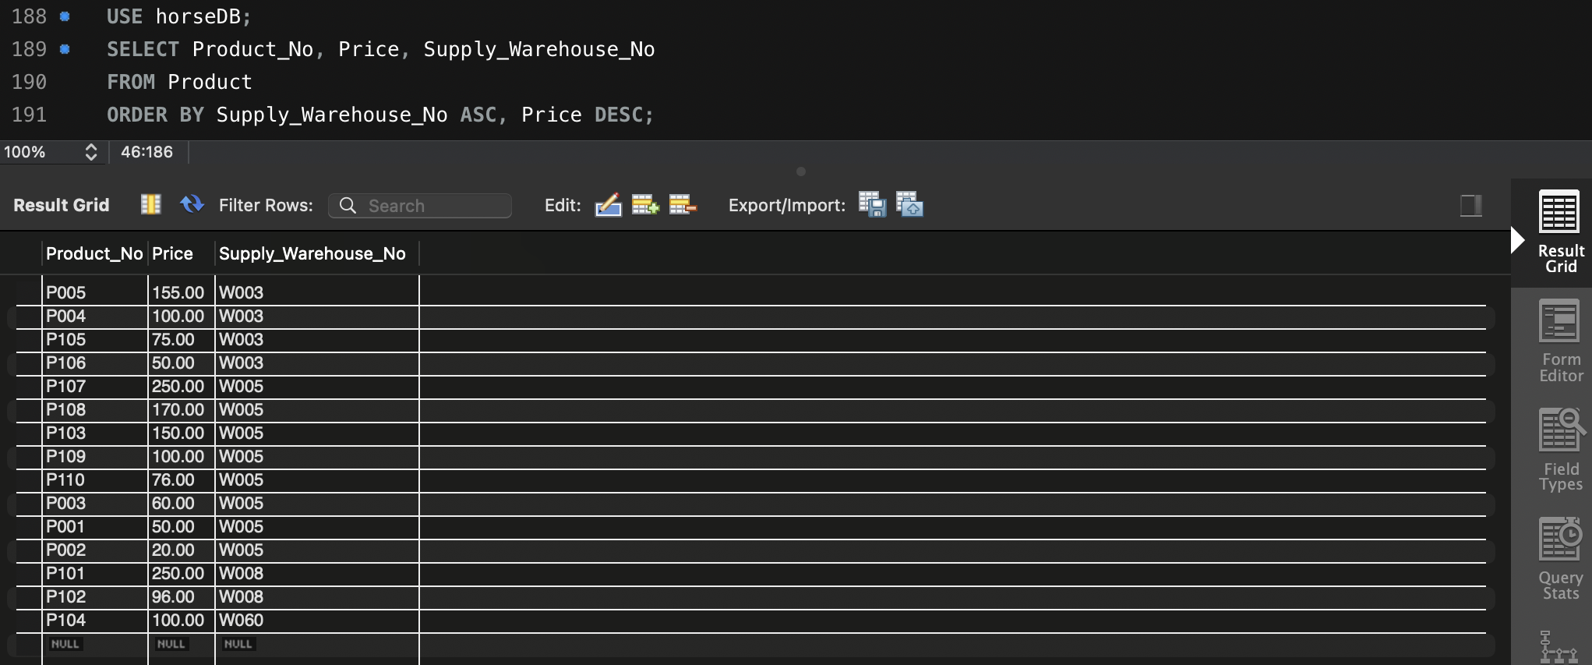

As we can see from the screenshot products are sorted by warehouse number (smallest to largest), and Within each warehouse, products are sorted by price (highest to lowest).

